Collection
It is a set of classes and interfaces that implements commonly used data structures

What is collection ?
Group of objects

Advantage
Immutability
Thread Safe
Polymorphic

Before collection → Array Vector HashTable

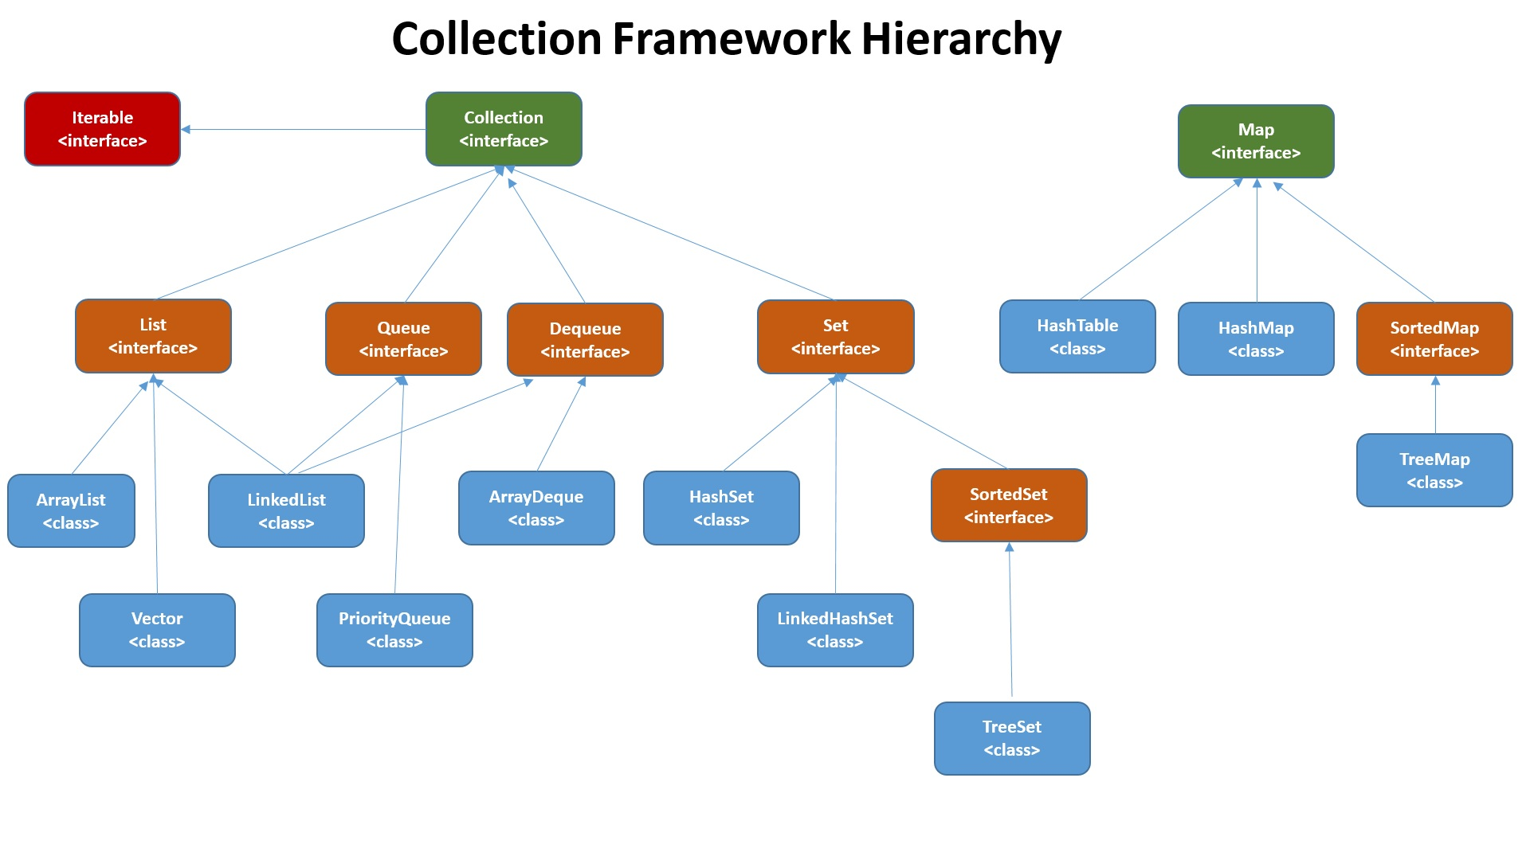

Iterator
hasNext()
next()

ListIterator
next()
previous()
hasNext()
hasPrevious()

List Interface Overview
ArrayList
LinkedList
Vector
Stack
CopyOnWriteArrayList

Used if insertion order , duplicates and index based access required

ArrayList
List implementation of array
Grows dynamically as elements are added to it
Internally uses Object[] to save elements
Implements RandomAccess interface which is a marker interface that allows element access by index
It has an initial capacity of 10
When an element is added to arraylist it first verifies its capacity to store the element
If it cannot store the element then array grows by 50% of its capacity
Ordered sequence of values
Duplicates allowed
Random access takes O(1) time
Adding element takes amortized constant time O(1)
Inserting/Deleting takes O(n) time
Searching takes O(n) time for unsorted array and O(log n) for a sorted one
Java ArrayList class is non-synchronized
In Java ArrayList class, manipulation is slow because a lot of shifting needs to have occurred if any element is removed from the array list.
Uses Iterator interface to traverse elements

Vector
default capacity is 10
after capacity is full capacity increases by 100%
it is synchronized
operations are slower as it is synchronized
uses Iterator and Enumeration interface for traversal

LinkedList
doubly linked list implementation
data manipulation is fast (insertion and deletion)
is not thread safe
allows duplicates
allows null
linked list requires a lot more memory than arraylist
avoid linkedlist prefer arraylist

CopyOnWriteArrayList

